AI Campus Hackathon – Day 1 Submission

Team Information
Team Name:
Team Members:
- Balbarosa, John Andrew
School/Campus: FEU Tech
Program & Year Level: BS Computer Science – 3rd Year
Team Representative Contact Information: jbalbarosa@fit.edu.ph

Project Title
CareerLens AI: An AI-Powered Career Intelligence Engine

Problem Statement
Students often struggle to create accurate, comprehensive, and tailored resumes because their achievements, projects, certifications, and experiences are scattered across multiple platforms such as LinkedIn, Facebook, GitHub, portfolios, and cloud storage. Over time, they forget significant accomplishments, making it difficult to represent their full capabilities when applying for internships, scholarships, competitions, or employment.
Traditional resume builders require users to manually remember, organize, and rewrite their experiences, creating unnecessary cognitive load. This process is time-consuming, error-prone, and often results in incomplete or generic resumes that fail to showcase the student’s actual potential.
The core problem is not simply writing a resume—it is reconstructing one’s professional history from fragmented digital information.

Target Users
Primary Users:
- College students preparing resumes for internships and employment.
- Graduating students entering the workforce.
Secondary Users:
- Scholarship applicants.
- Student organization leaders documenting achievements.
- Career Development Offices.
- Faculty mentors assisting students with career preparation.

User Persona Canvas

Persona Name
Juan Dela Cruz

User Type / Role
4th Year BS Computer Science Student

Background
Juan actively participates in hackathons, contributes to GitHub repositories, shares accomplishments on LinkedIn, and occasionally posts project updates on Facebook. Despite having numerous experiences, he struggles to remember everything when updating his resume.

Goals and Needs
- Create tailored resumes quickly.
- Highlight relevant experiences for different job applications.
- Identify missing technical and professional skills.
- Prepare for internships and full-time employment.

Pain Points
- Achievements are scattered across multiple platforms.
- Frequently forgets projects and certifications.
- Manual resume updates consume significant time.
- Difficult to customize resumes for different industries.

Current Behavior
- Searches old Facebook posts.
- Scrolls through LinkedIn activity.
- Opens multiple GitHub repositories.
- Reviews old resumes and certificates.
- Manually rewrites everything into a new document.

Motivations
- Save time.
- Increase chances of getting interviews.
- Present a complete and accurate professional profile.
- Focus more on learning new skills instead of repetitive documentation.

AI Opportunity
AI can automatically collect, classify, verify, and organize career-related information from multiple digital sources into a structured career knowledge base that can generate customized resumes and provide intelligent career recommendations.

Expected Benefit
- Faster resume creation.
- More complete representation of achievements.
- Personalized resumes for different industries.
- Actionable recommendations for future skill development.

Additional User Persona Canvas
Persona Name
Maria Santos
User Type / Role
Career Development Office (CDO) Career Advisor
Background
Maria is responsible for reviewing student resumes, conducting mock interviews, organizing career readiness workshops, and guiding graduating students in preparing for internships and employment. During peak application seasons, she reviews dozens of resumes each week, making it difficult to provide detailed and personalized feedback to every student.
Goals and Needs
- Help more students prepare high-quality resumes.
- Identify students' strengths and weaknesses efficiently.
- Provide personalized career recommendations.
- Reduce repetitive resume review tasks.
- Track students' career readiness over time.
Pain Points
- Students submit incomplete or outdated resumes.
- Significant time is spent identifying missing achievements or technical skills.
- Resume reviews become repetitive due to common formatting and content issues.
- Difficult to assess students' actual competencies from manually written resumes.
- Limited time prevents individualized coaching for every student.
Current Behavior
- Reviews resumes manually.
- Conducts one-on-one consultations.
- Uses resume checklists and templates.
- Suggests certifications and learning resources based on experience.
- Provides written feedback individually.
Motivations
- Improve employability of graduating students.
- Deliver more personalized career guidance.
- Spend more time mentoring rather than correcting resume formatting.
- Increase internship and employment success rates.
AI Opportunity
CareerLens AI automatically generates structured career profiles, highlights missing competencies, summarizes student experiences, and recommends learning paths. This enables career advisors to focus on mentoring, strategic career planning, and interview preparation instead of manually reconstructing students' experiences.
Expected Benefit
- Faster resume evaluation.
- More personalized student guidance.
- Increased efficiency during career consultations.
- Improved student employability.
- Data-driven insights into students' skill development and career readiness.

Proposed Solution
CareerLens AI is an AI-powered Career Intelligence Engine that transforms a student’s scattered digital footprint into a structured and searchable professional knowledge base.
The system securely imports information from platforms such as LinkedIn, GitHub, and optionally user-provided Facebook data. Using AI, it analyzes posts, repositories, project descriptions, and achievements to determine which information is professionally relevant.
The AI then:
- Extracts achievements, certifications, leadership experiences, projects, research, and technical skills.
- Removes irrelevant personal posts.
- Assigns semantic tags based on career domains (e.g., Full-Stack Development, Machine Learning, Cybersecurity, UI/UX, Data Science).
- Cross-references duplicated information from multiple sources.
- Builds a Career Knowledge Graph representing the user’s professional history.
Using this structured knowledge base, the platform can generate:
- Industry-specific resumes.
- ATS-friendly resumes.
- Portfolio summaries.
- Interview preparation materials.
- LinkedIn profile improvements.
- Skill gap analysis.
- Personalized recommendations for certifications, projects, and learning paths.
Unlike traditional resume builders, CareerLens AI reduces the cognitive effort of recalling and organizing years of experiences, allowing students to focus on career growth rather than documentation.

Expected Impact
CareerLens AI empowers students to present their complete professional identity with confidence while significantly reducing the time required to prepare application materials.
Expected benefits include:
- Reduced cognitive load during resume preparation.
- Increased resume accuracy and completeness.
- Better internship and employment readiness.
- Improved alignment between student skills and industry requirements.
- Continuous tracking of professional growth throughout college.
- Enhanced career guidance through AI-generated skill gap analysis and recommendations.
The solution can also support Career Development Offices by helping students maintain up-to-date professional profiles throughout their academic journey.

AI Tools to Be Used

OpenAI
- ChatGPT (brainstorming, prompt engineering, resume generation, skill analysis)
- OpenAI API (classification, information extraction, tagging, recommendation generation)
- Codex (prototype development and code generation)

Other Technologies
- Python
- Playwright / Selenium (data collection with user permission)
- GitHub API
- LinkedIn data export or authorized import
- FastAPI / Flask
- React / Next.js
- PostgreSQL / SQLite
- Vector Database (optional for semantic retrieval)

Initial Mockup / Concept Illustration
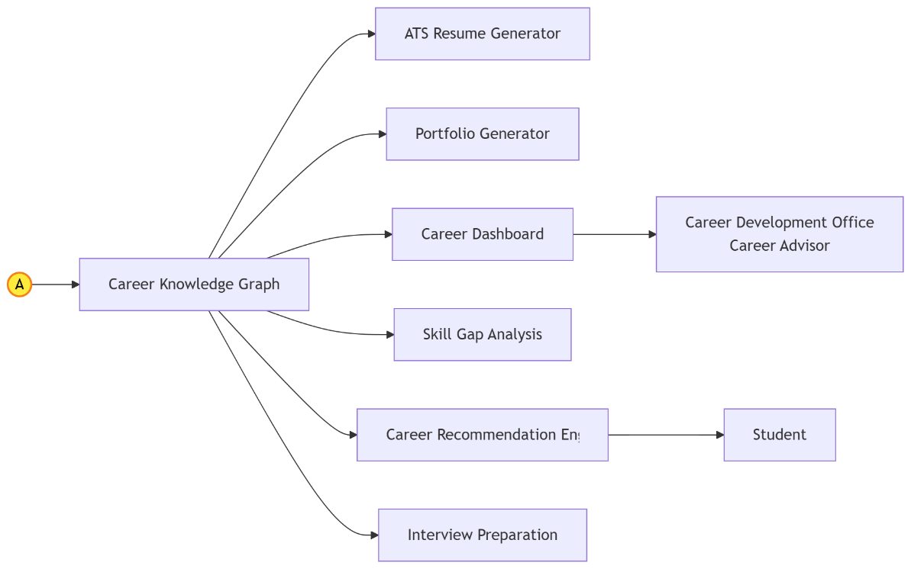
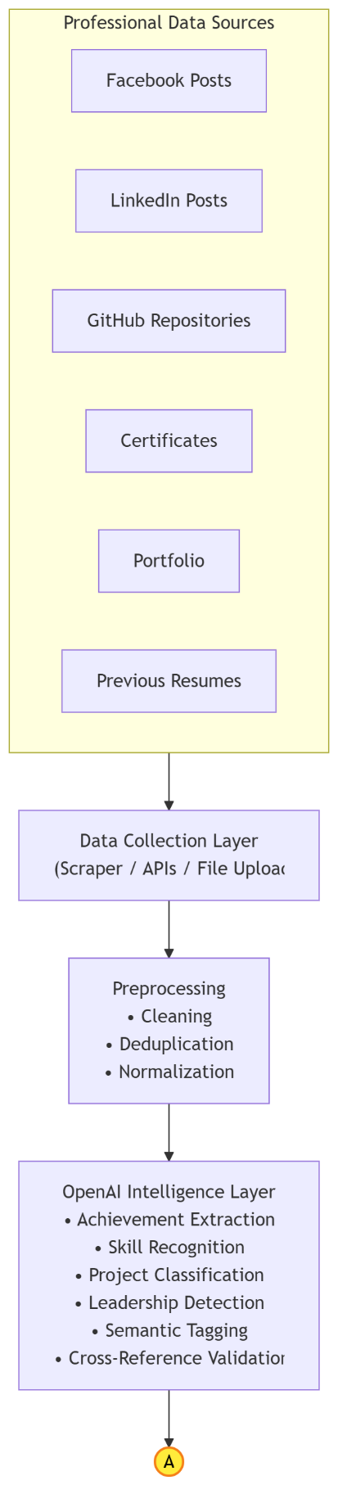

Future Enhancements
- Continuous career profile updates.
- Integration with certificates and digital badges.
- AI interview coaching.
- Portfolio website generation.
- Scholarship and internship matching.
- Career progression analytics dashboard.

Reference:
Mermaid UML
flowchart TD

subgraph Sources["Professional Data Sources"]
FB[Facebook Posts]
LI[LinkedIn Posts]
GH[GitHub Repositories]
CERT[Certificates]
PORT[Portfolio]
RES[Previous Resumes]
end

Sources --> COLLECT

COLLECT["Data Collection Layer<br>(Scraper / APIs / File Upload)"]

COLLECT --> PRE

PRE["Preprocessing<br>• Cleaning<br>• Deduplication<br>• Normalization"]

PRE --> AI

AI["OpenAI Intelligence Layer<br>• Achievement Extraction<br>• Skill Recognition<br>• Project Classification<br>• Leadership Detection<br>• Semantic Tagging<br>• Cross-Reference Validation"]

%% Off-page connector going out
AI --> ConnectorA((A))

%% Styling for the connector to make it stand out
classDef connector fill:#ffeb3b,stroke:#f57f17,stroke-width:2px,color:#000;
class ConnectorA connector;

flowchart LR

%% Off-page connector coming in
ConnectorA((A)) --> GRAPH["Career Knowledge Graph"]

%% Grouping outputs to create a clean vertical stack in LR mode
GRAPH --> RESUME["ATS Resume Generator"]
GRAPH --> PORTFOLIO["Portfolio Generator"]
GRAPH --> DASH["Career Dashboard"]
GRAPH --> GAP["Skill Gap Analysis"]
GRAPH --> ADVISOR["Career Recommendation Engine"]
GRAPH --> INTERVIEW["Interview Preparation"]

%% Connections to end-users
DASH --> CDO["Career Development Office<br>Career Advisor"]
ADVISOR --> USER["Student"]

%% Styling for the connector to make it stand out
classDef connector fill:#ffeb3b,stroke:#f57f17,stroke-width:2px,color:#000;
class ConnectorA connector;

